ACADEMIC YEAR
2025-2025
ODD SEM
NEWS LETTER
JULY 2025 – DEC 2025

ACADEMIC YEAR
2025-2025
ODD SEM
NEWS LETTER
JULY 2025 – DEC 2025

ABSTRACT
FACULTY FDP’S
S.NO | STAFF NAME | EVENT NAME / TITLE | CONDUCTED BY | DURATION
1 | Mrs.M.SHUNMUGA SANKARI, HOD-EEE | INTRODUCTION TO MACHINE LEARNING | NPTEL - AICTE | JUL – OCT 2025
2 | Mr. S. GANESH, AP-EEE | ATAL FACULTY DEVELOPMENT PROGRAM | NEHRU INSTITUTE OF TECHNOLOGY | 03-11-2025  to  08-11-2025
3 | Mrs.M.SHUNMUGA SANKARI, HOD-EEE | Market Ka Eklavya - FACULTY DEVELOPMENT PROGRAM | NSDL TECHNOLOGY, TRUST & REACH | 08-11-2025
4 | Mrs .M. SHUNMUGA SANKARI, HOD-EEE  Mr. T. KAMALKUMAR, AP-EEE  Mr. S. GANESH, AP-EEE  Mrs. C. ANUSHA, AP-EEE  Mr. M. ARJUNKUMAR, AP-EEE | FACULTY DEVELOPMENT PROGRAM | NEHRU INSTITUTE OF TECHNOLOGY | 18-11-2025
5 | Mr. T. KAMALKUMAR, AP-EEE | ONE DAY FACULTY DEVELOPMENT PROGRAM | NEHRU INSTITUTE OF TECHNOLOGY | 12-12-2025
6 | Mr. T. KAMALKUMAR, AP-EEE  Mr. S. GANESH, AP-EEE | SIX DAYS FACULTY DEVELOPMENT PROGRAM | AMS COLLEGE OF ENGINEERING | 15-12-2025  to  20-12-2025

INDUSTRIAL VISITS
S.NO | STAFF COORDINATOR | ORGANISATION | PARTICIPATED STUDENTS | DATE
1 | Mr. S. GANESH, AP-EEE  Mrs. C. ANUSHA, AP-EEE | NORTH CHENNAI THERMAL POWER STATION STAGE – II, ENNORE. | II,III & IV YEAR STUDENTS | 08-08-2025
2 | Mr. S. GANESH, AP-EEE  Mrs. C. ANUSHA, AP-EEE | BSNL | II & III YEAR STUDENTS | 12-09-2025

DEPT ORGANISED EVENTS
S.NO | NAME OF THE EVENT | RESOURCE PERSON | DATE
1 | 16TH NATIONAL LEVEL SYMPOSIUM GNISTA 2K25 | Dr. BALAGURU, SSN | 08-08-2025
2 | NTLS Knowlytix - WORKSHOP | Mr. V. SUJEETH VISHNU, NTLS | 30-07-2025  To  31-07-2025

STUDENT OTHER EVENTS
S.NO | NAME OF THE EVENT | VENUE | PARTICIPATED STUDENTS | DATE
1 | SPECIAL CORPORATE SESSION | AUDITORIUM | III & IV YEAR STUDENTS | 09-08-2025
2 | TNSCST 2025 | ONLINE | IV YEAR (8 BATCHES) | 25-08-2025
3 | SMART INDIA HACKATHON | ONLINE | IV YEAR (8 BATCHES) | 17-09-2025
4 | BLOOD DONATION CAMP | TJS ARTS & SCIENCE COLLEGE, PERUVOYAL | II YEAR (3 STUDENTS) | 14-11-2025

S.NO | NAME OF THE TITLE | PRESENTED BY | ATTENDED BY | DATE
1 | DESIGN PATENTS IN BATTERY PACK CONFIGURATION | Mr. SHYAM SUNDAR  MANAGING DIRECTOR,  TVS OKINAWA AUTO TECH | II , III & IV YEAR STUDENTS | 01-08-2025
2 | DATA SCIENCE | Mr. LOKESH KUMAR | II , III & IV YEAR STUDENTS | 06-10-2025
TECHNICAL SEMINAR

ALUMNI INTERACTION
S.NO | NAME OF THE ALUMNI | ATTENDED BY | DATE
1 | KARTHICK B – SHAREKHAN COMPANY LIMITED, CHETPET. | II YEAR STUDENTS | 13-08-2025
2 | SAIKRISHNAN RADHAKRISHNAN | II & III & IV YEAR STUDENTS | 14-11-2025

INTERNSHIP
S.NO | NAME OF THE ORGANISATION | ATTENDED BY | DATE
1 | JANA ENGINEERING | III YEAR STUDENT | 16-09-2025
2 | NORTH CHENNAI THERMAL POWER STATION STAGE – II, ENNORE. | II YEAR STUDENTS | 15-12-2025
3 | NORTH CHENNAI THERMAL POWER STATION STAGE – III, ENNORE. | III YEAR STUDENTS | 18-12-2025
4 | TANGEDCO, PULICAT | II YEAR STUDENTS | 26-12-2025

JUL – OCT 2025
NPTEL FACULTY DEVELOPMENT PROGRAM
NPTEL – AICTE Faculty Development Programme conducted in the title of “INTRODUCTION TO MACHINE LEARNING” was attended by Mrs.M.SHUNMUGA SANKARI, HOD-EEE
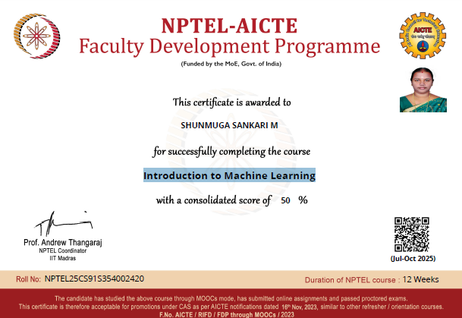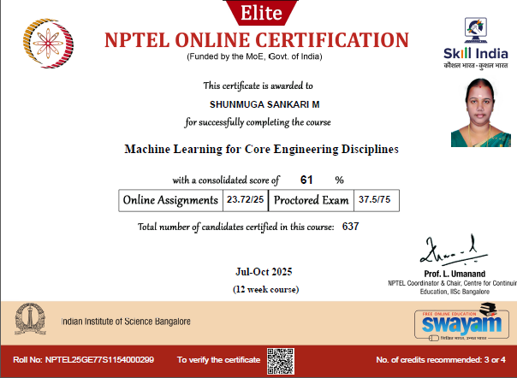
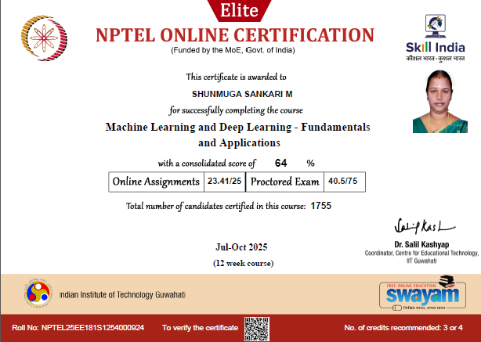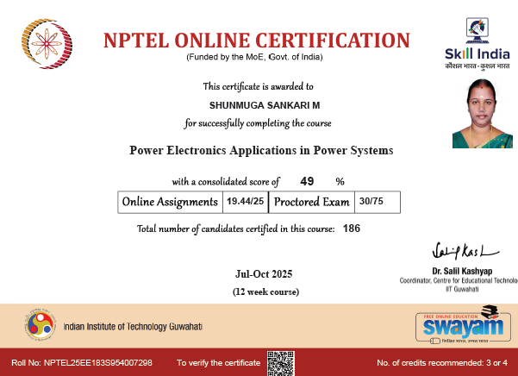

30-07-2025 to 31-07-2025
WORKSHOP
Mr. V. SUJEETH VISHNU from NTLS Consultancy OPC Pvt Ltd has conducted a Two day Workshop from 30-07-2025 to 31-07-2025 with the students of II, III and IV Year at Seminar Hall.

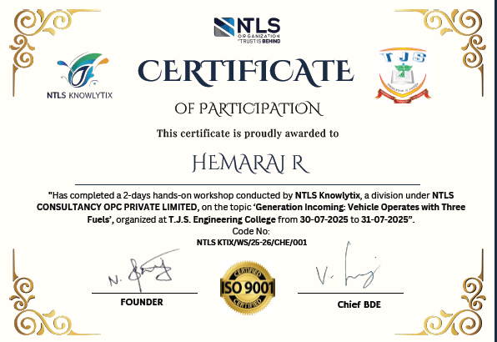 | 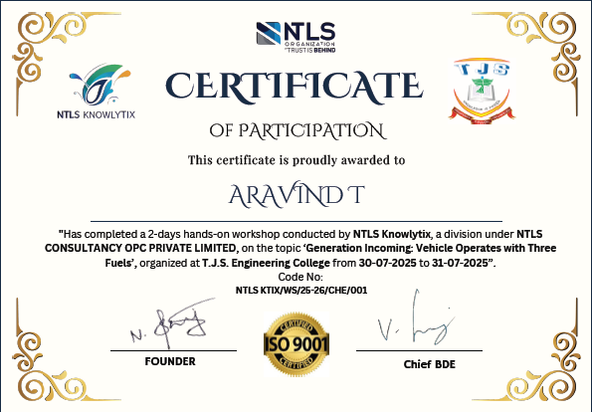
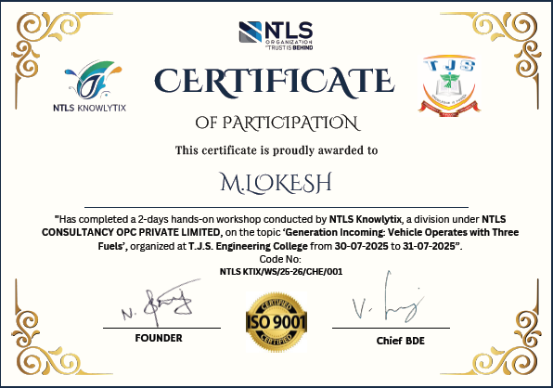 | 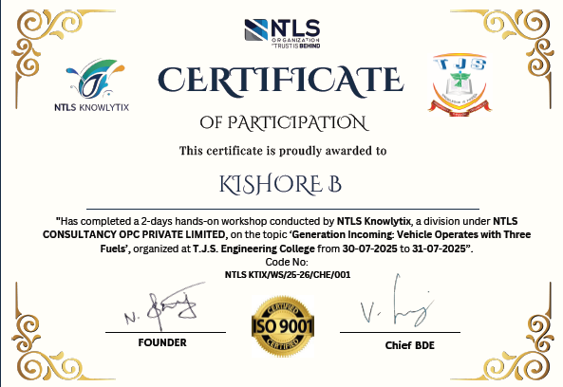

01-08-2025
SEMINAR
One day Seminar on Design Patents in Battery Pack Configuration by Mr. SHYAM SUNDAR MANAGING DIRECTOR, TVS OKINAWA AUTO TECH to the students of the II & III Year students.

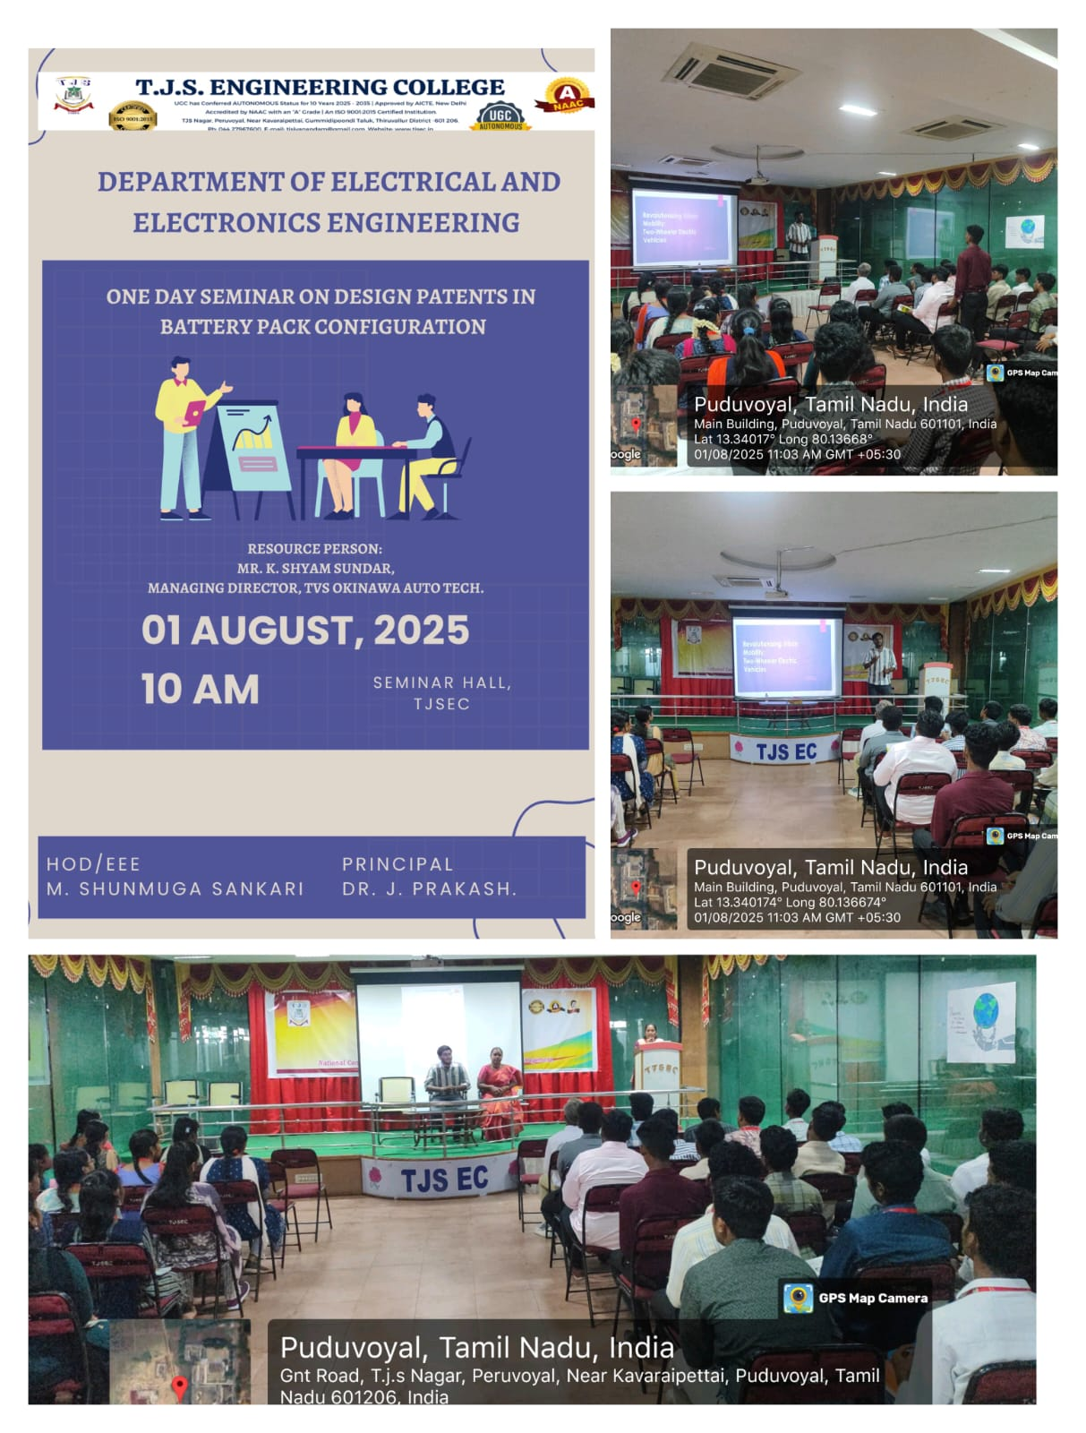

08-08-2025
INDUSTRIAL VISIT
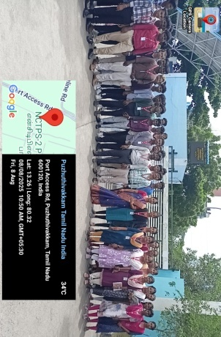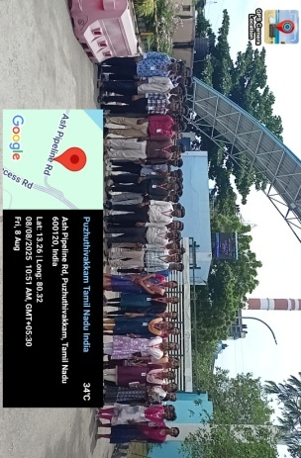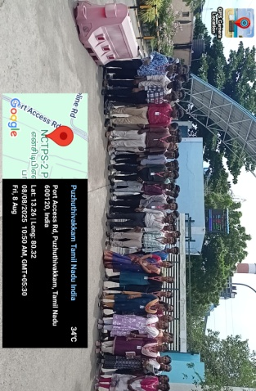

The II, III and IV Year students went for Industrial Visit for NORTH CHENNAI THERMAL POWER STATION STAGE –II, ENNORE.
09-08-2025
SPECIAL CORPORATE SESSION
Our III & IV students attended the Training and Placement programme on the title of “Special Corporate Session on Interview Readiness” was conducted by Mr. Sarath Chandar Sukumar General Manager- HR (Vaken Technologies).

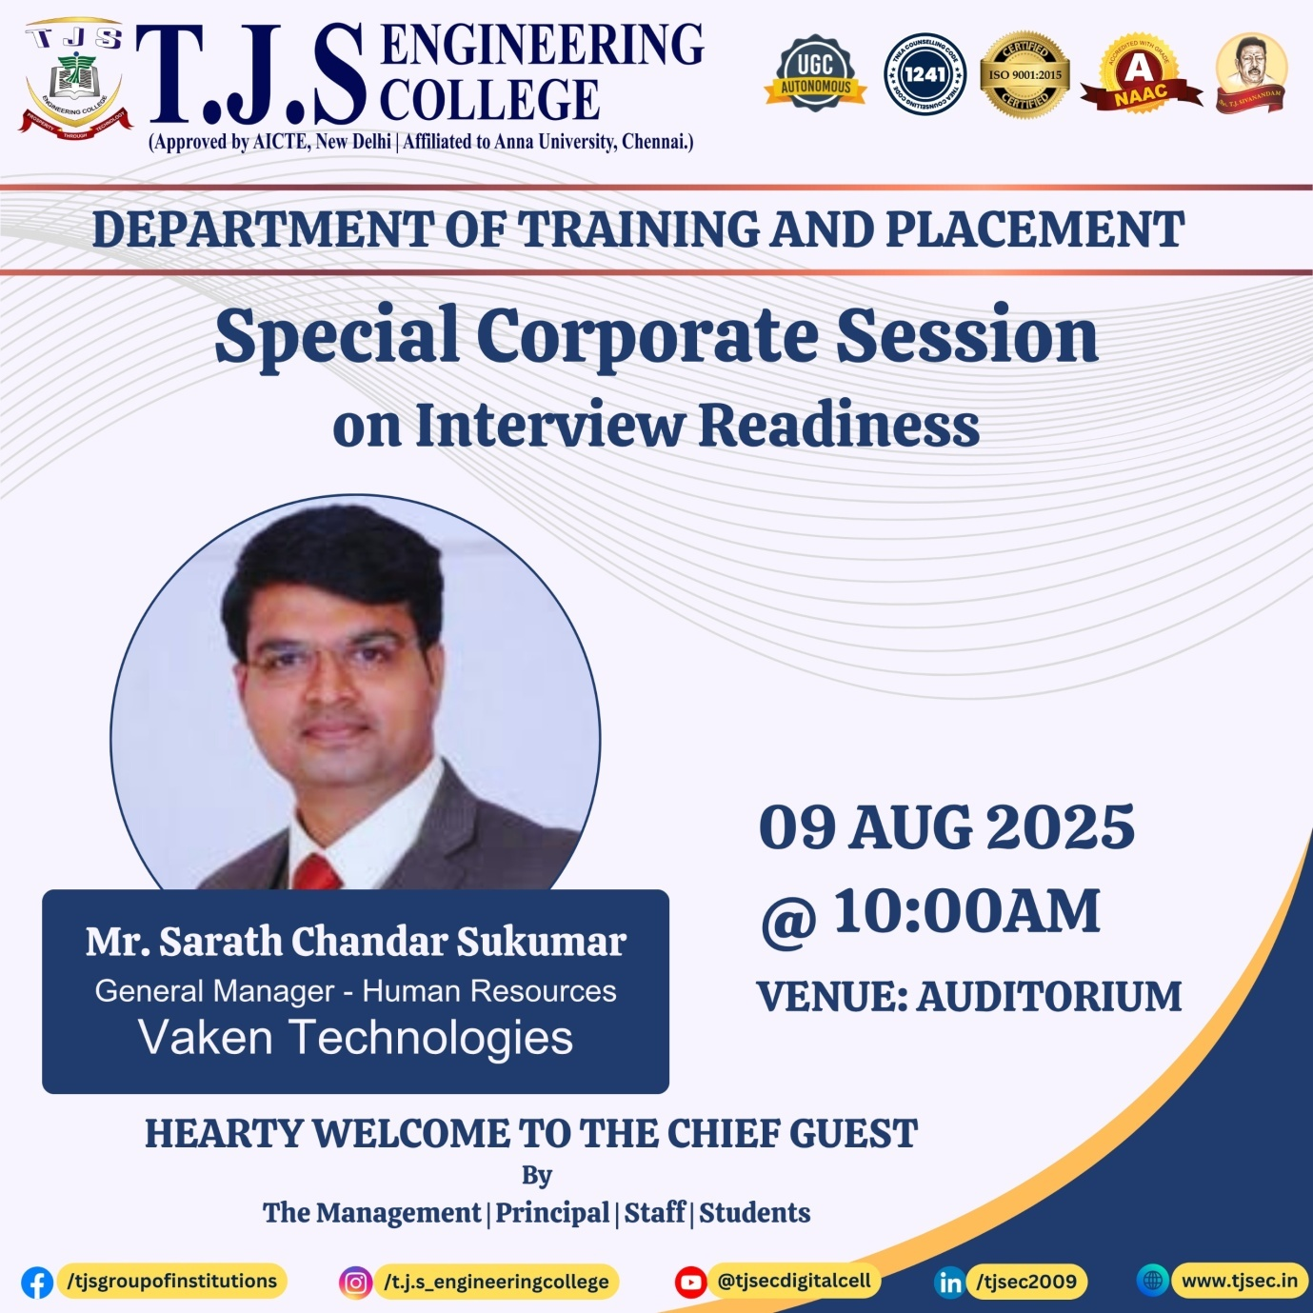

13-08-2025
ALUMNI INTERACTION
ALUMNI student Karthick B – 112819105304 - Sharekhan Company Limited, Chetpat came interact with our II Year students for career growth and future scope.

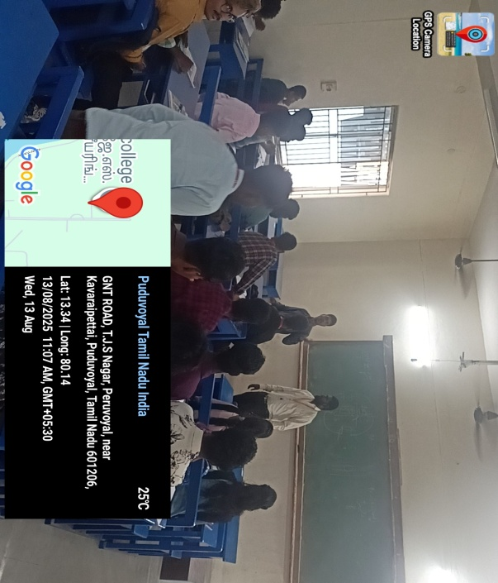 | 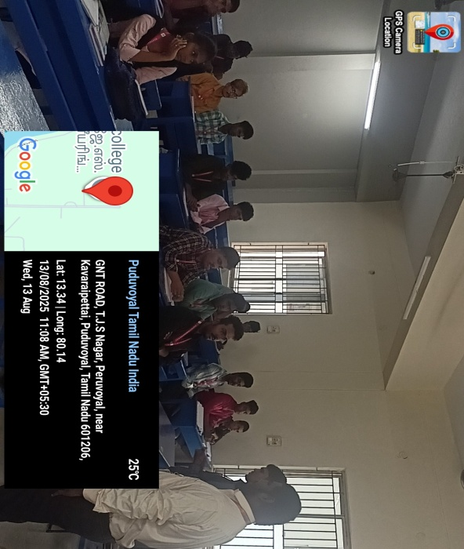
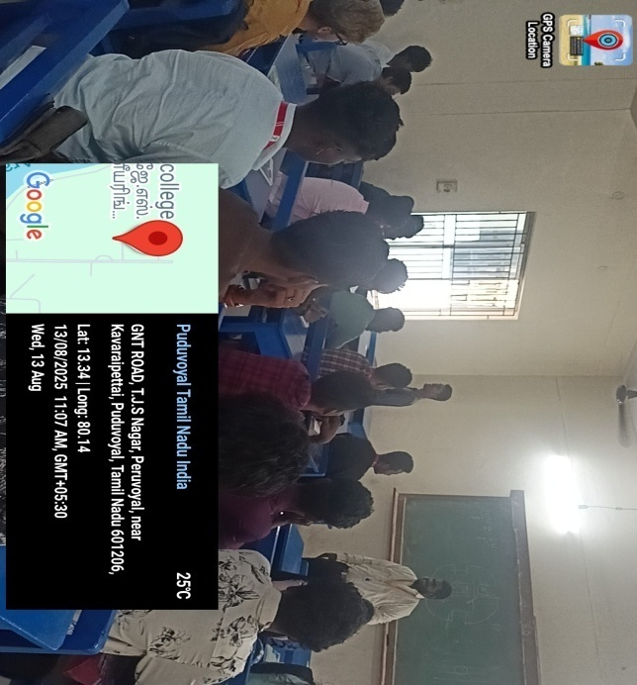 | 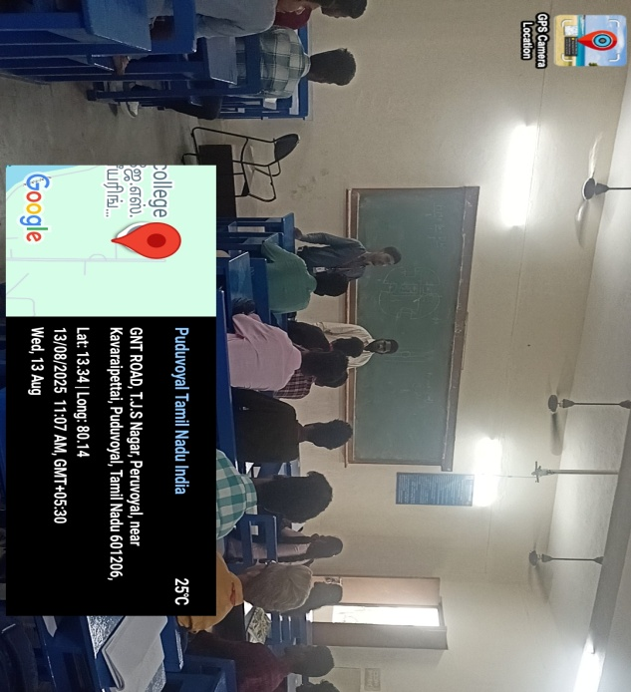

25-08-2025
PROJECT EXPO - TNSCST

NAME OF THE GUIDE | BATCH MEMBERS
Mr. T. KAMALKUMAR, AP-EEE | OVIYA.R  SANJAY.U  SAMUEL.R
Mr. S. GANESH, AP-EEE | NAGESHWARI.R  LOGENDHERAN.R  SANJAY.V
Mr. S. GANESH, AP-EEE | KARTHICK.K  SAKTHIVEL.V
Mrs. C. ANUSHA, AP-EEE | KAVIYA SRI.S  SANTHOSH.M
Mr. M. ARJUNKUMAR, AP-EEE | KALAISELVI.P  MAGESH.N
Mr. M. ARJUNKUMAR, AP-EEE | SANDHIYA.A.S  SURYAPRASATH.T
Mrs.M.SHUNMUGA SANKARI, HOD-EEE | HEMARAJ.R  JAYASREEN.M  VIJAY.R

12-09-2025
INDUSTRIAL VISIT
Our II & III Year students went to Industrial visit for BSNL with the coordination of the Faculty members listed below:
1. Mr. S. GANESH, AP-EEE
2. Mrs. C. ANUSHA, AP-EEE

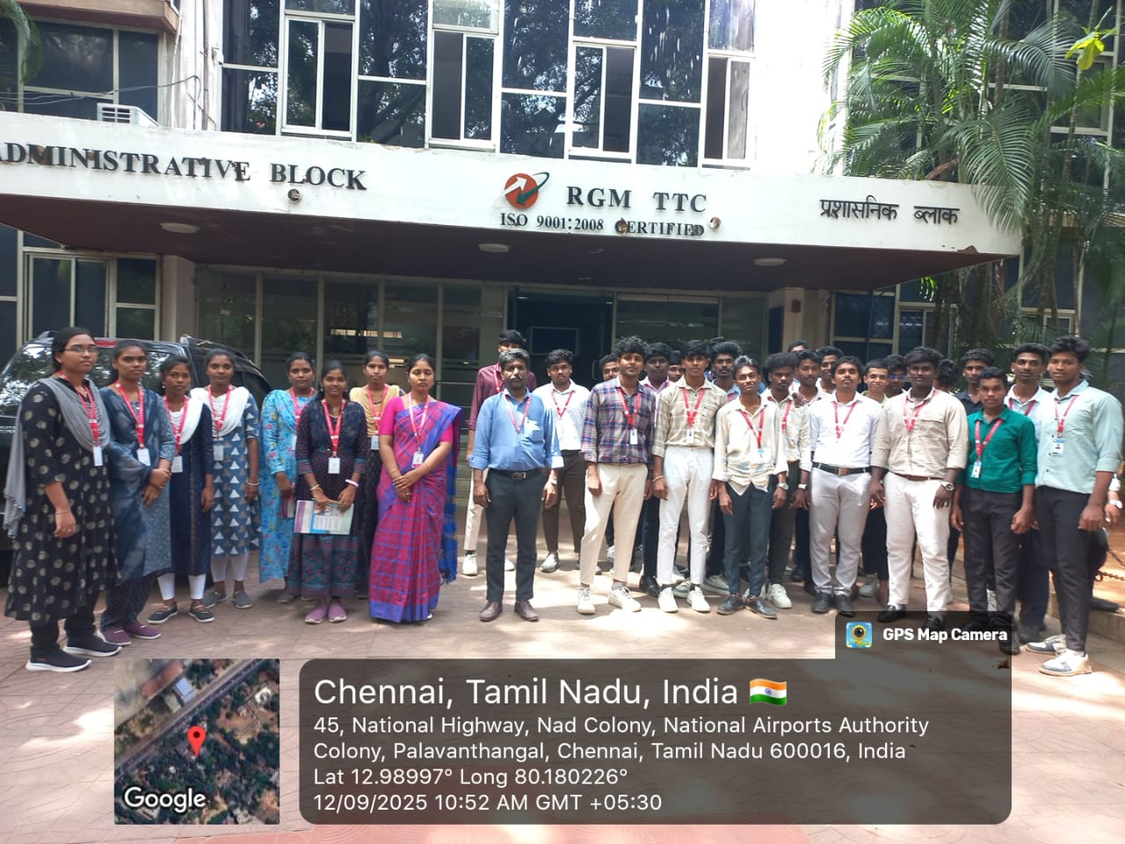 | 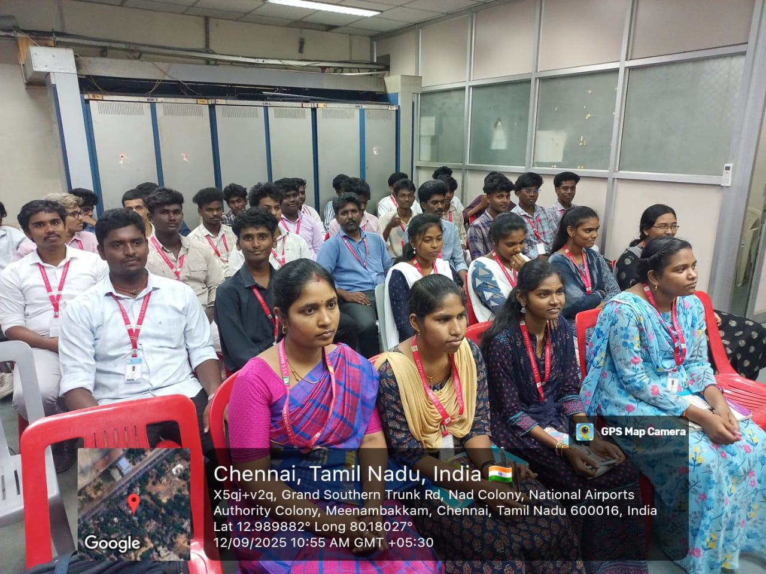
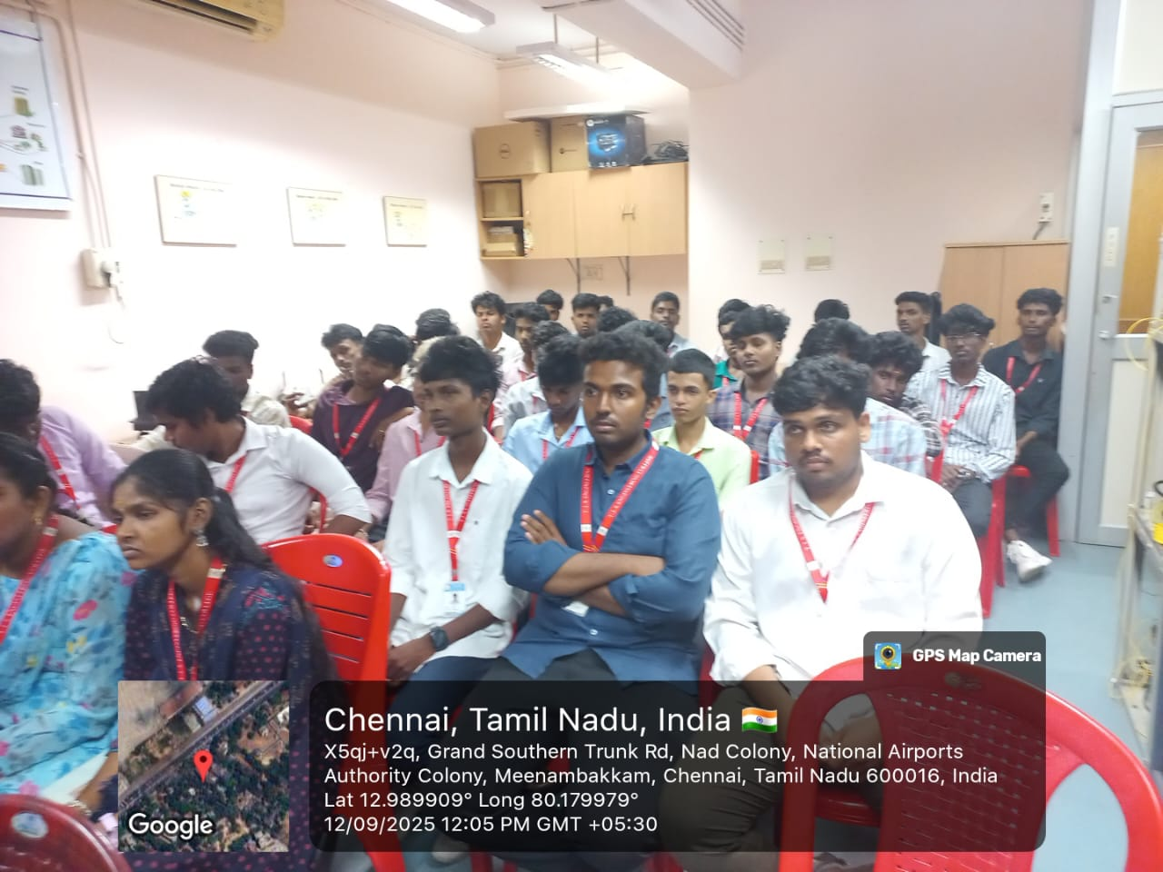 | 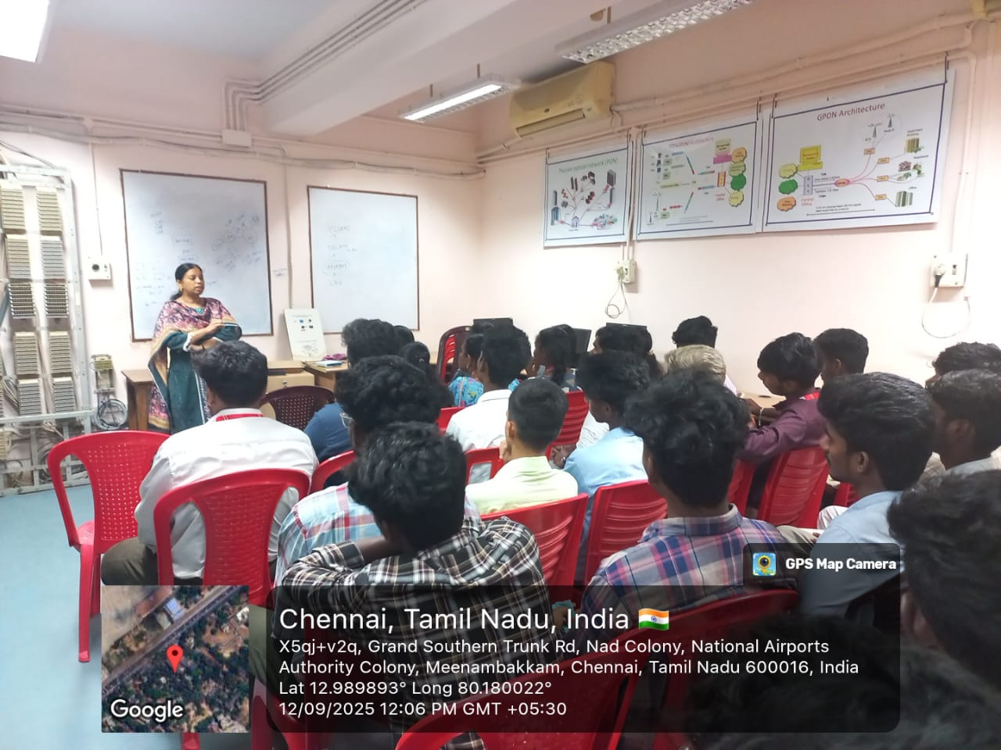
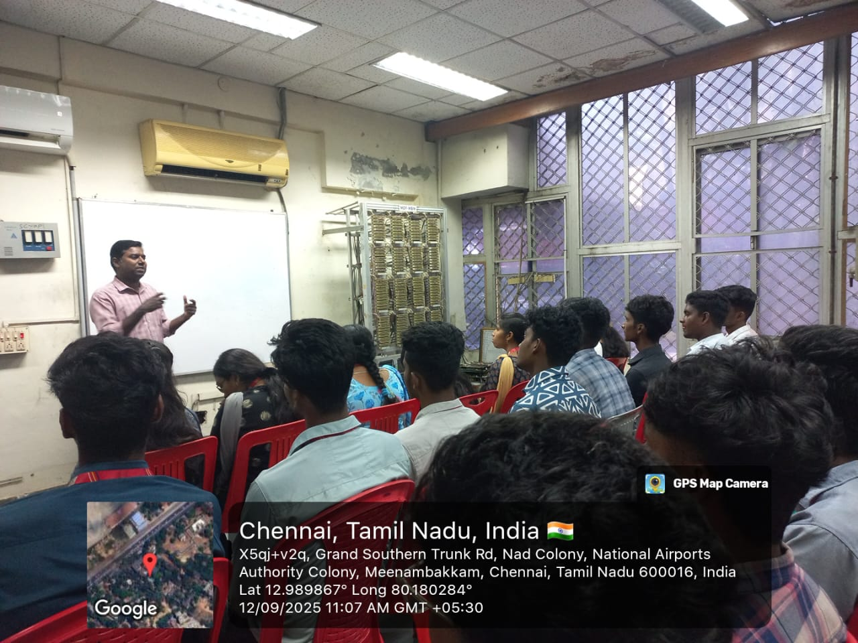 | 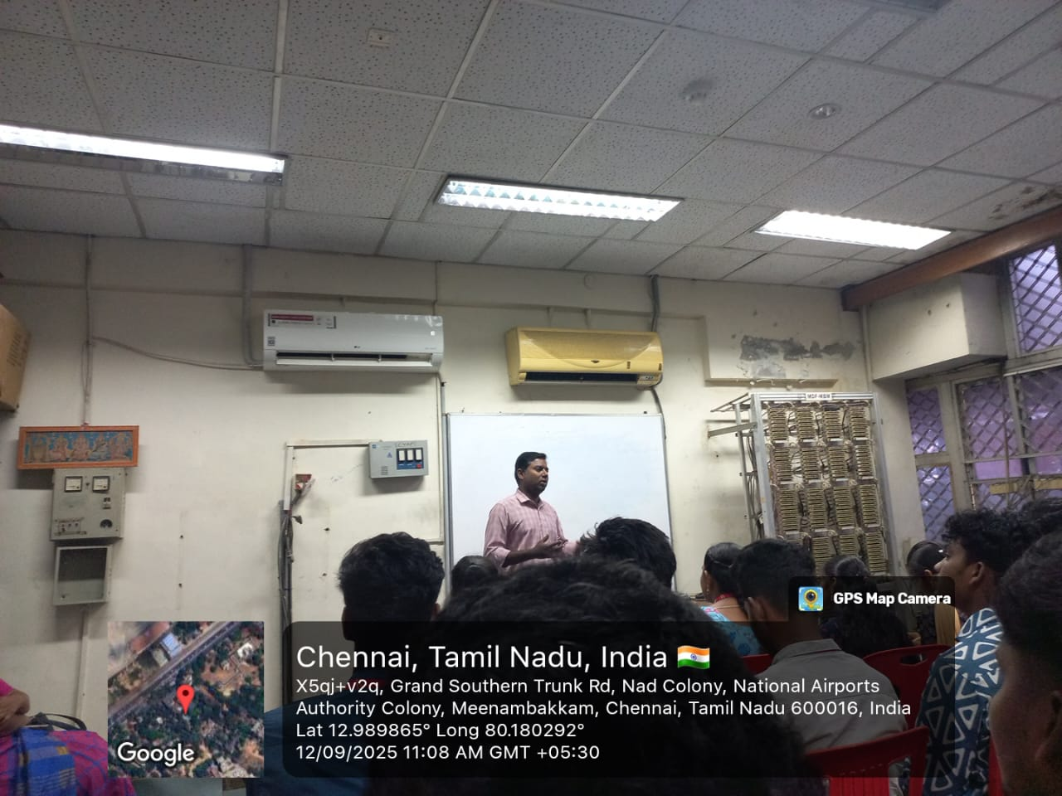
17-09-2025
PROJECT EXPO
SMART INDIA HACKATHON- 8 BATCHES
NAME OF THE TEAM | TEAM LEADER | TEAM MEMBERS
MAGNETRONS | KALAISELVI.P | MAGESH.N  DEEPANJAL.M  KAMALESH.T  DIWAKAR.S  DHANASEKAR.L
THE STRIVES | KAVIYA SRI.S | SANTHOSH.M  NETHAJI.P  VIGNESH.M  HARISH RAJ.S  ANANDH.R
ONE PIECES | OVIYA.R | SANJAY.U  SAMUEL.R  PERARASU.K  KALAIVANAN.K.S  LOKESH.M
THUNDER BOLTS | HEMARAJ.R | JAYASREEN.M  VIJAY.R  HINDUJA.V  MADHAVAN.N  SHYAM.E
TECH TRANSFORMERS | SAKTHIVEL.V | KARTHICK.K  KAMESH.G  VIJAYAKUMAR.V  LINGESHWARAN.N  EZHILVANI.E
CATAIN VOLT | GOPIRAJ.M | AVINASH.K  POORNIMA.K  LAVANYA.G  SANJAIRAJ.E  MADHAN.J
EEE WARRIORS | NAGESHWARI.R | LOGENDHERAN.R  SANJAY.V  HARINIYA.S  HEMAVATHI.R
ELECTRO TITANZ | SANDHIYA.A.S | SURYAPRASATH.T  ARAVIND.T  ANGUMUTHU.A  ARCHANA.D  DEENAKUMAR.D

16-09-2025
INTERNSHIP
Our II Year student attended 15 days Internship at “JANA ENGINEERING INDUSTRIES, GUMMIDIPOONDI”
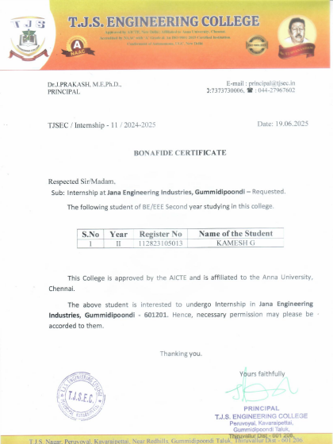

06-10-2025
SEMINAR
Our II, III & IV Year students attended One day Seminar on Data Science which was conducted by LOKESH KUMAR.
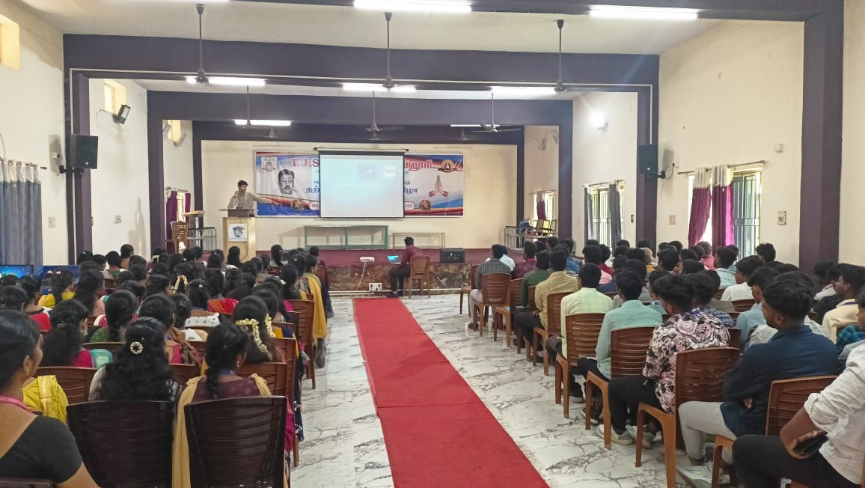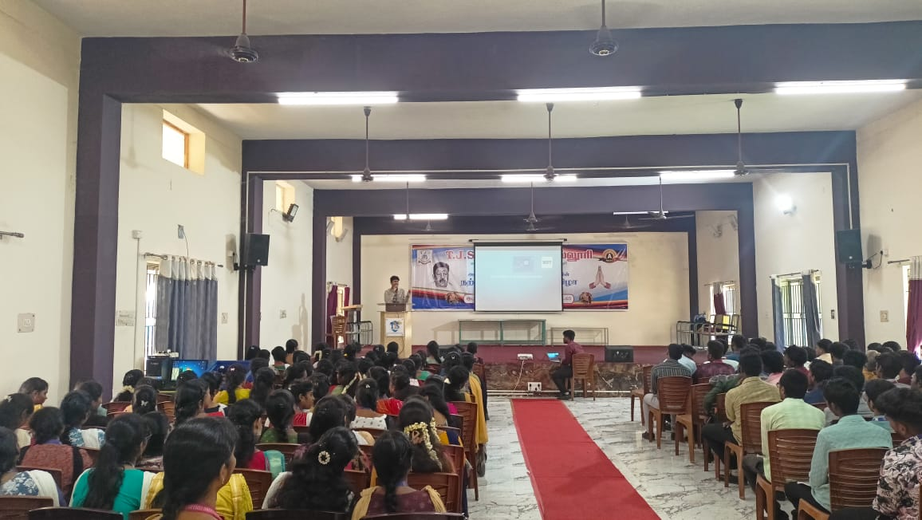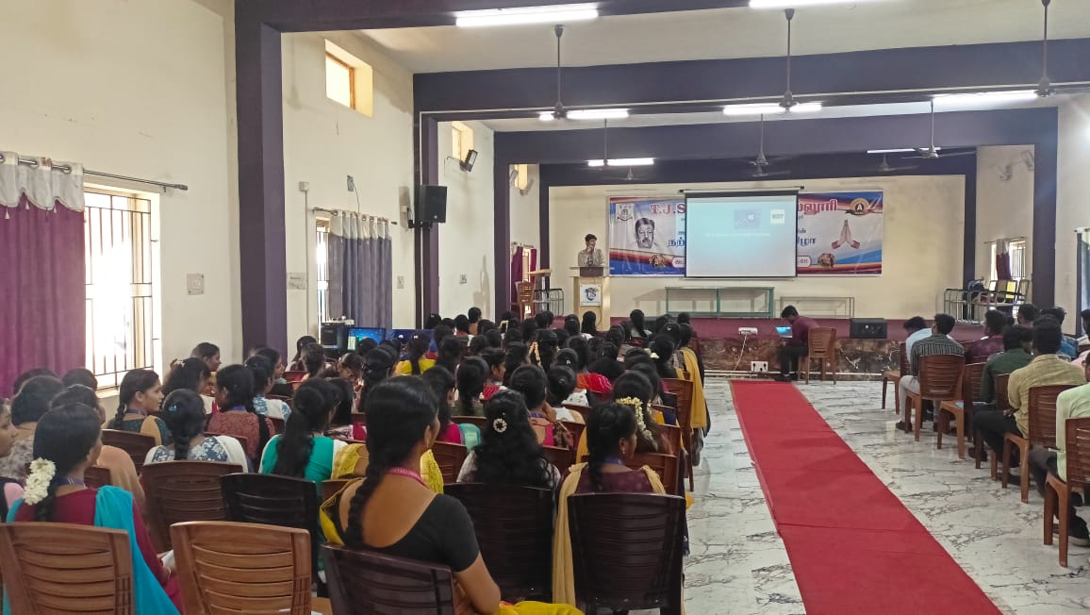

28-10-2025
SYMPOSIUM – GNISTA 2K25
16th National Level Technical Symposium organised with the chief guest “Dr. BALAGURU – SSN”
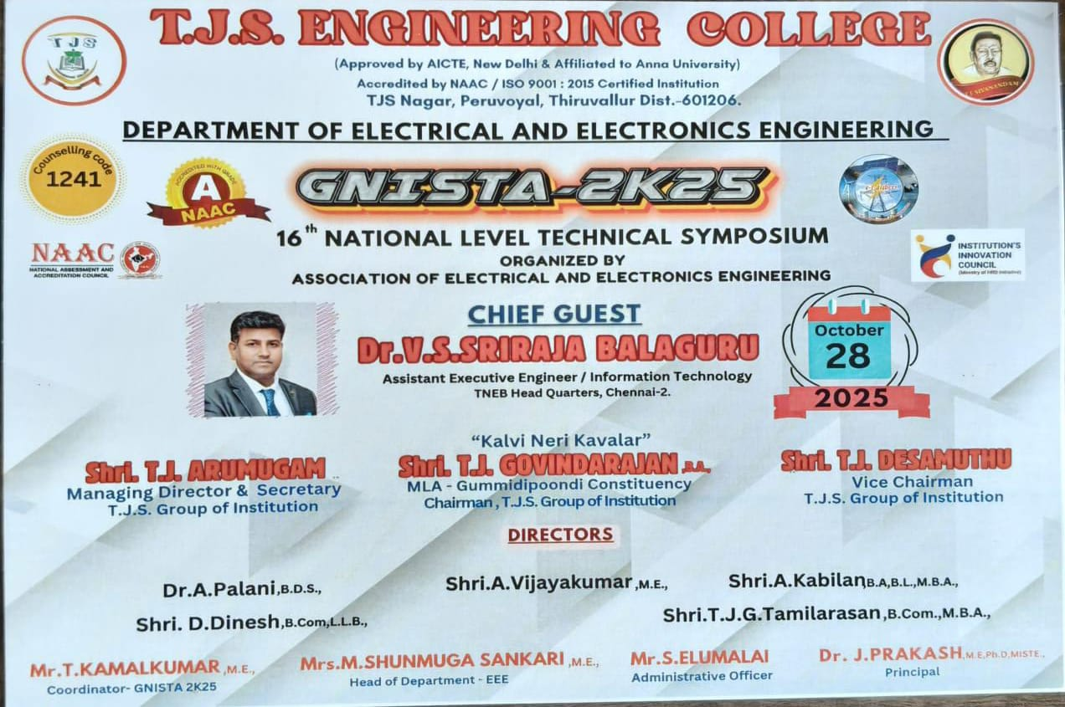
03-11-2025 TO 08-11-2025
ATAL FACULTY DEVELOPMENT PROGRAM
AICTE Training and Learning (ATAL) Academy & Nehru Institute of Technology conducted FACULTY DEVELOPMENT PROGRAM in the title “The Evolving Landscape in Teaching and Research: AI and Data Approaches” was attended by

1. Mr. S. GANESH, AP-EEE

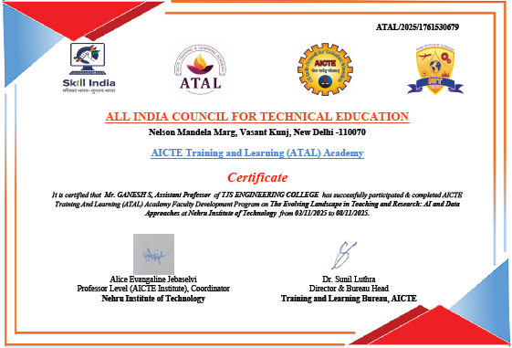

08-11-2025
FACULTY DEVELOPMENT PROGRAM
NSDL TECHNOLOGY, TRUST & REACH has conducted Faculty Development Program on the title of “MARKET KA EKLAVYA” was attended by Mrs.M.SHUNMUGA SANKARI, HOD-EEE
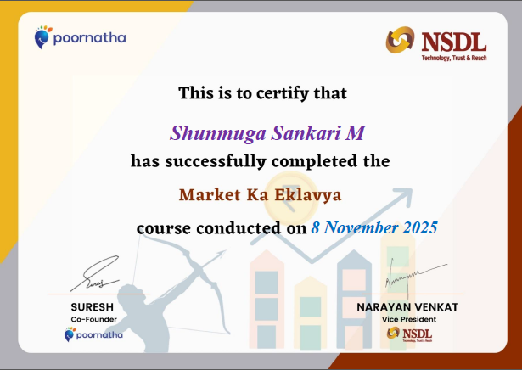
14-11-2025
ALUMNI INTERACTION
Saikrishnan Radhakrishnan (Batch – 2021) working in Tata Consultancy Services has met with II and III Year Students

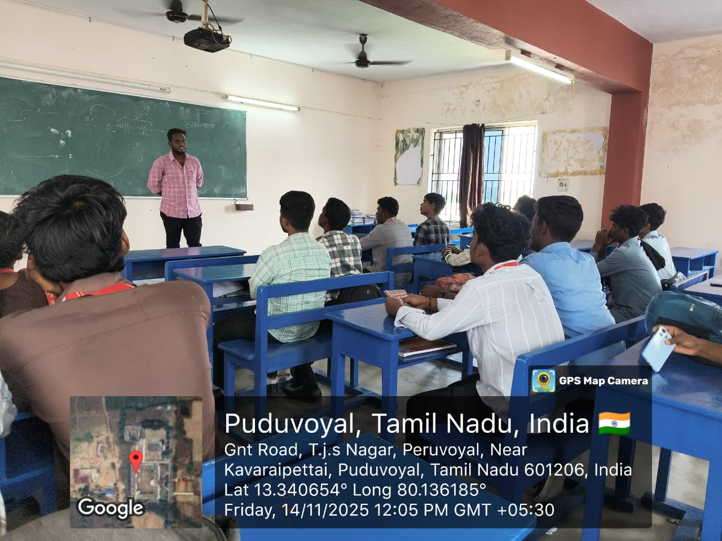 | 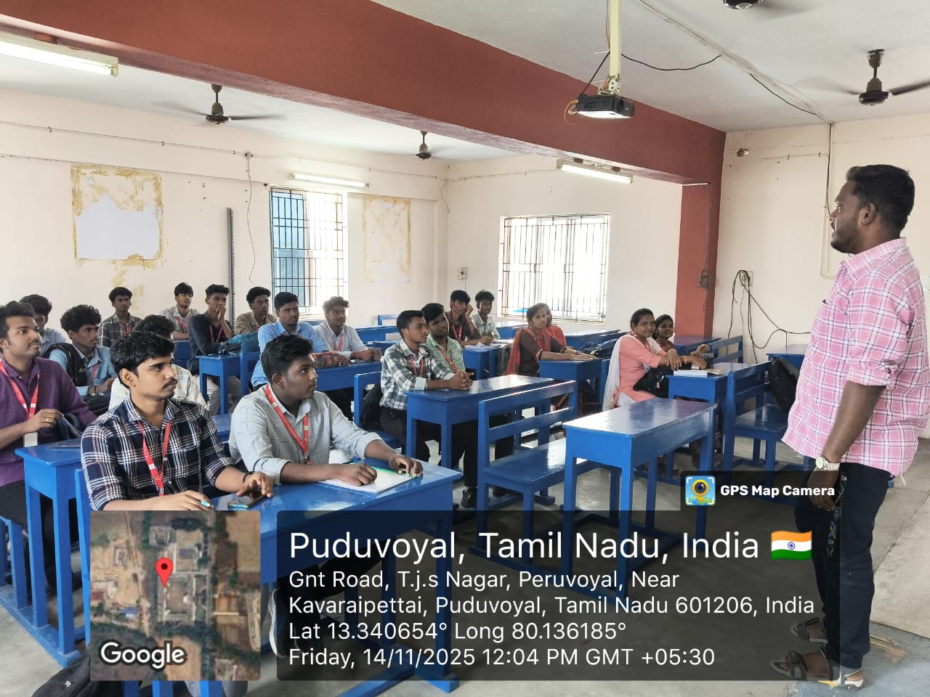
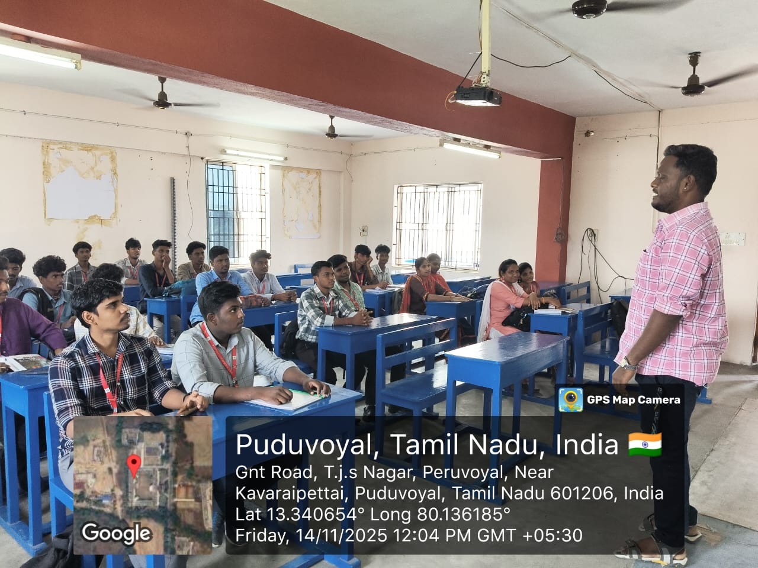 | 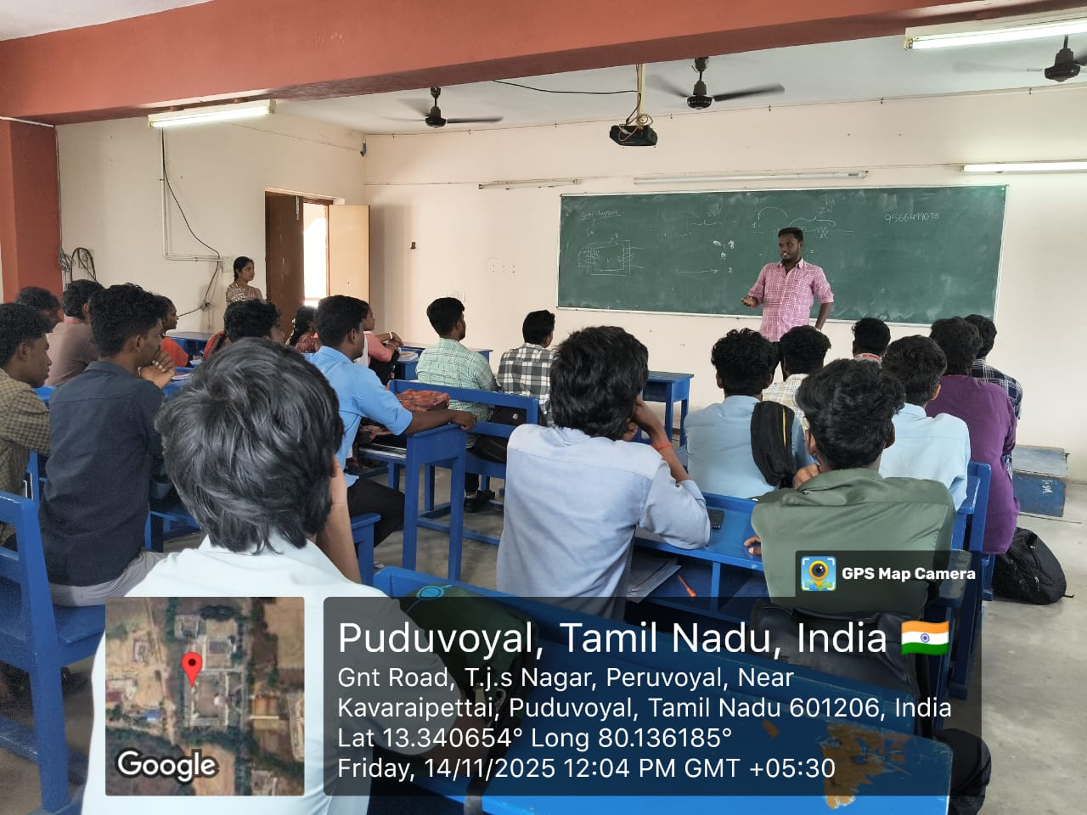

14-11-2025
BLOOD DONATION CAMP
Our II year students 3 members have donated their valuable BLOOD to the “Rela Hospital” which is conducted on TJS ARTS & SCIENCE COLLEGE, PERUVOYAL.
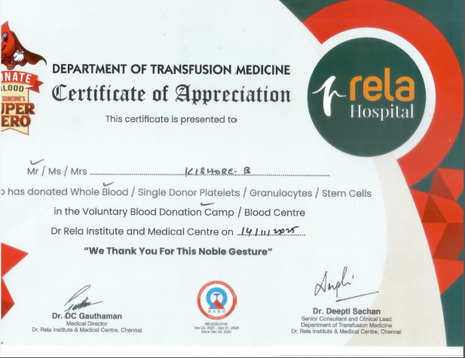
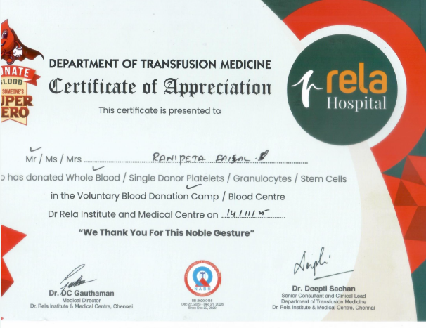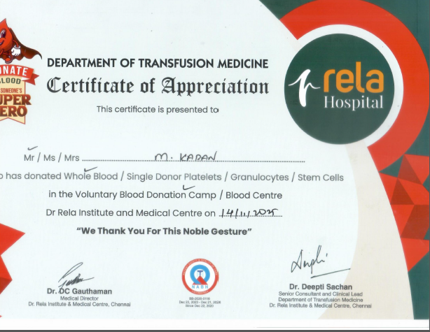
18-11-2025
FACULTY DEVELOPMENT PROGRAM
Nehru Institute of Technology, Coimbatore has conducted a One Day Faculty Development Program on the title of “SUSTAINABLE COMPUTING AND GREEN IT SOLUTIONS”. The following staffs attended the program in online mode
Mrs .M. SHUNMUGA SANKARI, HOD-EEE
Mr. T. KAMALKUMAR, AP-EEE
Mr. S. GANESH, AP-EEE
Mrs. C. ANUSHA, AP-EEE
Mr. M. ARJUNKUMAR, AP-EEE

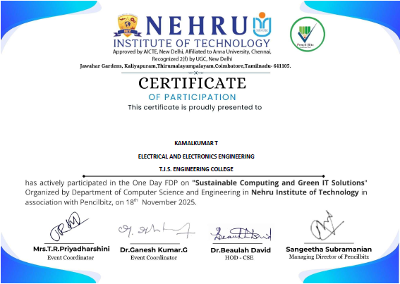 |  | 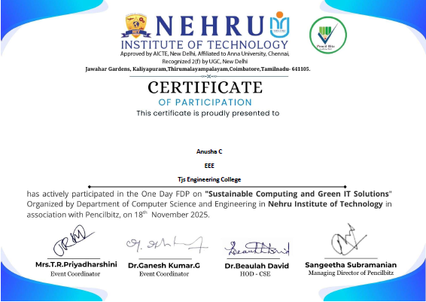
 | 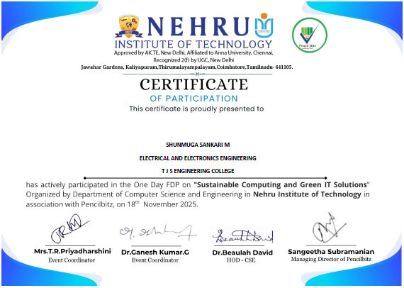
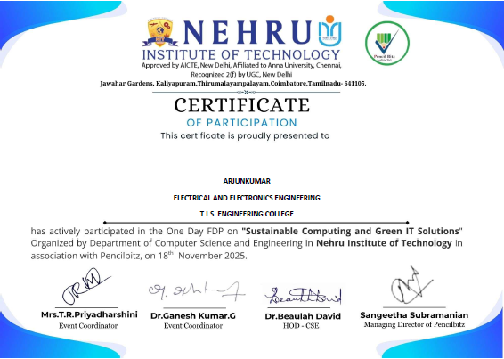 |  | 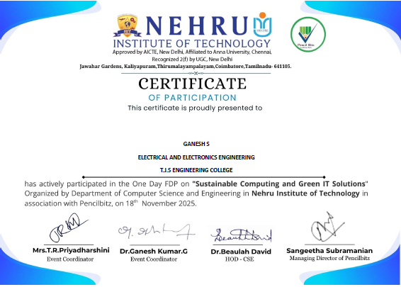

12-12-2025
FACULTY DEVELOPMENT PROGRAM
One day Faculty Development Programme has been conducted by “NEHRU INSTITUTE OF TECHNOLOGY, COIMBATORE” in online mode with the title of “QUANTUM COMPUTING: BASIC AND APPLICATIONS” which was attended by following Faculty members
- Mr. T. KAMALKUMAR, AP-EEE

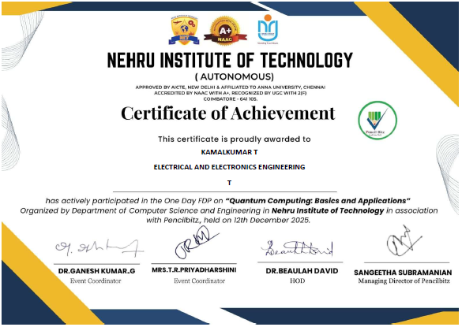

15-12-2025 TO 20-12-2025
FACULTY DEVELOPMENT PROGRAM
Six days Faculty Development Programme has been conducted by “AMS COLLEGE OF ENGINEERING” in online mode with the title of “ELECTRIC VEHICLES – BREAKTHROUGHS AND CHALLENGES” which was attended by following Faculty members
Mrs .M. SHUNMUGA SANKARI, HOD-EEE
Mr. T. KAMALKUMAR, AP-EEE
Mr. S. GANESH, AP-EEE
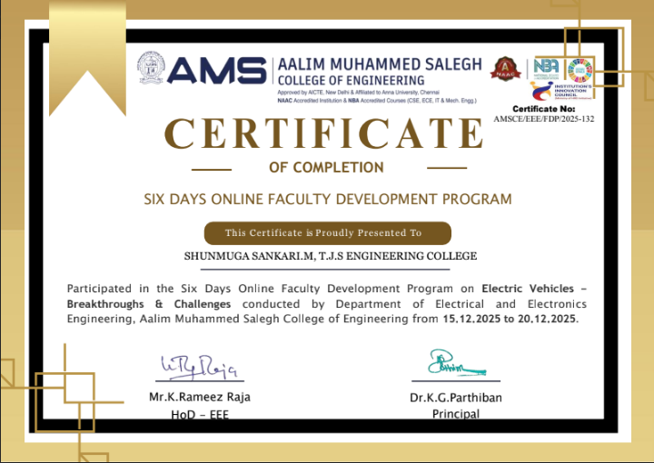
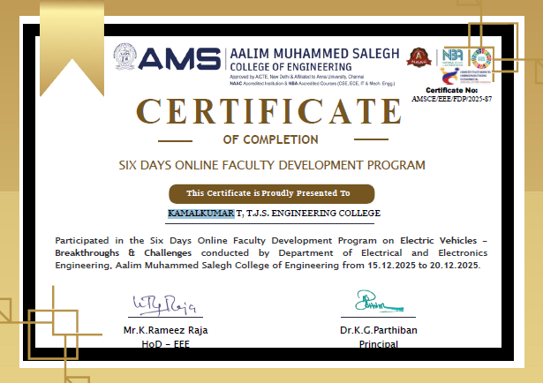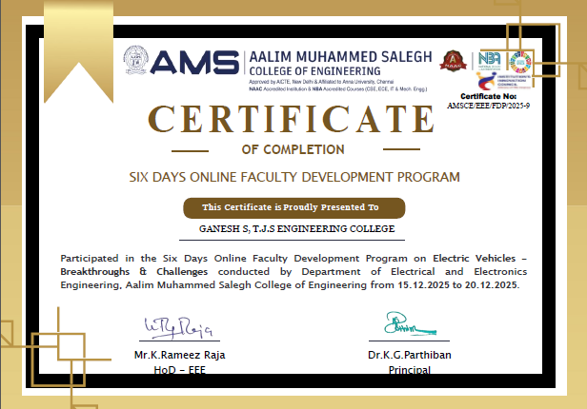

18-12-2025
INTERNSHIP
Our III Year students list of 14 members went to attend “INTERNSHIP” at NCTPS- III Ennore.
The following students went for internship
1. ANGUMUTHU A
2. DEENAKUMAR D
3. DHANASEKAR L
4. KAMALESH T
5. LINGESHWARAN N
6. PERARASU K
7. MADHAVAN N
8. DEEPANJAL M
9. EZHILVANI E
10. HARINYA S
11. HEMAVATHI R
12. HINDUJA V
13. LAVANYA G
14. POORNIMA K
26-12-2025
INTERNSHIP
Our II Year students list of 9 members went to attended internship at TANGEDCO, Pulicat for 15 days.
The following students went for internship
1. SABARI MANIKANDAN K
2. KISHORE B
3. EDWIN PAUL.M
4. KARAN M
5. YOKESH S
6. JAYAPRAKASH D
7. ANANDH R
8. THARUN D
9. PARTHIAN P

